FAGALA VILLAGE NURSERY RESTORATION PROJECT
Project Name: | FAGALA VILLAGE NURSERY RESTORATION PROJECT
Start Date | APRIL, 2017
End Date | MAY, 2021
Project Location: | Kyetume Village, Nsuube Village and Kauga Lower Village
Project Proponents | Fagala Green Institute, Kyetume Tree Planting Group, and Nsuube Native Tree Farmers
Total Project Cost | $41,395.5
Community contribution | $32,400
Proponent contribution | $955.5
Amount sought | $8,040
Project Objectives | - Avail native tree seedlings to participating and neighboring Villages
 | - Restore threatened indigenous tree species; Milicia execlsa, Prunus africana, Mahogany, Meiosopsis eminii
 | - Establish and maintain productive and village based healthy seed stands of native tree species
 | - Provided back up support to bigger restoration projects through provision of healthy seedlings of native tree
Project field outputs | - 2ha seed stand/mother garden for each of the candidate species (Meiosopsis eminii, Milicia excelsa and Prunus africana) for each of the candidate species
 | - One village nursery for each of the participating communities with a production capacity of at least 30,000 seedlings per year
 | - 5ha of each of the candidate species per candidate village on private land
Community benefits
 | - Prepare participating communities for voluntary carbon markets
 | - Improve climate conditions of participating villages
 | - Make money from sell of native seeds and seedlings
 | - Acquire nursery and essential tree planting techniques
 | - Benefit from medicinal properties of Prunus africana
Benefits to investors
Marketing of project outputs | - The project is looking at commercially rewarding participants through sell of “allowable” timber volumes to give back to the landowners besides credits from voluntary carbon markets. For that matter; the project seeks an investor capable of not only widening the income base of the project but also with the capacity to market such project output for the benefit of the landowner, investor and the environment
Improvement of company public image | - The project seeks to benefit its investors through promotion of their corporate social responsibility and public image; we think that it will be honest for the investing companies to use their promotion of project activities to build their social corporate images around the success of this project and to use project field images and videos in preparation of their periodic social and environment accountabilities
Make companies carbon neutral | - All carbon derived from the project shall exclusively go to companies that have invested in the project; for they have contributed towards emission reduction and a such our investors shall looking at becoming carbon neutral
Training and internship field sites | - Participating companies shall be to use project sites as fields of training and internship for their graduate trainees or internees for all project field sites shall always be regarded as sites of operation for all participating companies
BASIC PROJECT FACTS AND FIGURES
Total area to be planted | - 2ha of mother garden per candidate native species (Meiosopsis eminii, Milicia excelsa and Prunus africana) = 2ha x 3 = 6ha of mother/ yardstick gardens
 | - ½ acre of any of the candidate species per participating farmer
 | - Total number of participating farmers = 500
 | - Total acreage of participating farmers = 500 x ½ = 250Acreas
 | - Total number of acres = 6ha x 2.47 = 14.82acres + 250acres = 264.82acres to be planted
Total number of tree to be planted | - For Mother gardens / seed stands; spacing = 10m x 10m = 100m²  - Total square meters for mother garden; 4,046.856m² x 14.47acres = 58,558m² of mother gardens to be planted
 | - Each tree shall occupy; 100m² ; hence; total number of mother trees = 58,558m²/100m² = 585 mother trees to be planted
 | - Number of trees on to be planted by individual farmers; spacing; 5mx5m = 25m² to be occupied per tree on community land
 | - Total amount of community land in sq.meters = 250acres x 4,000m² = 1,000,000m²
 | - No. of trees to be planted = 1,000,000m²/25m² = 40,000 trees to be planted by community members
 | - Total number of trees to be planted= (trees in mother gardens + tree planted by community) = (40,000trees + 585trees) = 40,585 trees to planted in total
Number of seedlings required | - Total number of trees to be planted (40,585) + 20% loss (expected in nursery and field) = (20/100 x 40,585) = 811.6
 | - Total Seedlings required = 40,585 + 812 = 41,397 seedlings required
 | - Number of seedlings per species = total number of seedlings/3 (No. of species to be planted) = 41,397 / 3 = 13,797 seedlings per species
Number of seeds required | - Seeds of Meiosopsis required ; 1kg of Meiosopsis seed = 500plants
 | - Required No. of seeds = seedlings required (13,797); No. of Kg of seeds required = 13,797 / 500 = 27.6kg of seeds of Meiosopsis eminii required
 | - Seeds of Prunus africana required; 1kg of Prunus seeds = 3,000plants
 | - No. of plants required = 13,797; and kg of seeds = 13,797 / 3,000 = 4.6kg of Prunus african
 | - Seeds of Milicia excelsa required; 1kg of Milicia excelsa = 10,000plants
 | - No. of plants required = 13,797; hence; hence seeds required = 13,797 / 10,000 = 1.4kg of Milicia excelsa required
Potting materials required | - Number of pots = number of seedlings needed
 | - Number of seedlings needed = 41,397seedlings
 | - 1kg of polyethene = 800 empty pots of 3inches cut to 4.8cm x 12cm
 | - Hence, kg of polyethene needed = 41,397 / 800 = 51.7kg
Nursery soils required | - 1m³ of mixed soils = 800 pots of 3inches cut 4.8cm x 12cm
 | - Hence; 800pots = 1m³ and 41,397 = 41,397 / 800 = 51.7m³ of soils required
 | - And 1m² = 17wheelbarrows = 51.7 x 17 = 879 wheelbarrows
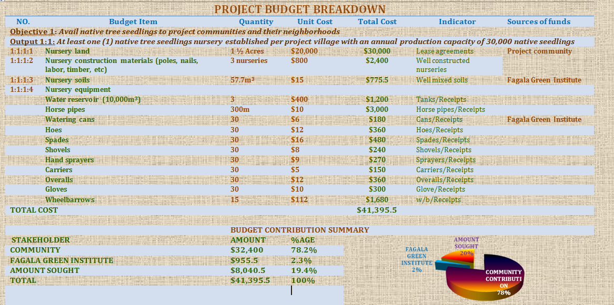

1hactare = 2.47acres
1cre = 4046.856m²

